How Retention Aids Improve Paper Quality & Reduce Wastage
The Indian paper industry is at a crucial juncture. With increasing environmental regulations, rising input costs, and demand for higher-quality grades, manufacturers are constantly seeking process enhancements. One powerful tool that's transforming the way paper is made in India is retention aids.
Retention aids are chemicals added to the wet end of the paper machine to help fine fibers, fillers, and other materials bind to the sheet—rather than being lost in the water loop. Let's explore how these solutions dramatically improve paper quality and reduce wastage, especially in Indian conditions.

Introduction to Retention Aids

What Are Retention Aids?
Retention aids are high-molecular-weight chemicals that help retain small particles—like fibers, fillers (such as calcium carbonate or clay), and other additives—on the paper sheet during formation. Common types include cationic polyacrylamide (CPAM), colloidal silica, and bentonite.

Why They Matter in Indian Paper Mills
In India, many paper mills use recycled fiber and operate with lower-cost raw materials. This increases fines, ash, and other suspended solids. Without proper retention, these particles are lost, leading to:
- Poor formation
- High chemical consumption
- Increased effluent load
- Sheet defects and rejections
Retention aids solve these problems by anchoring valuable components to the sheet.

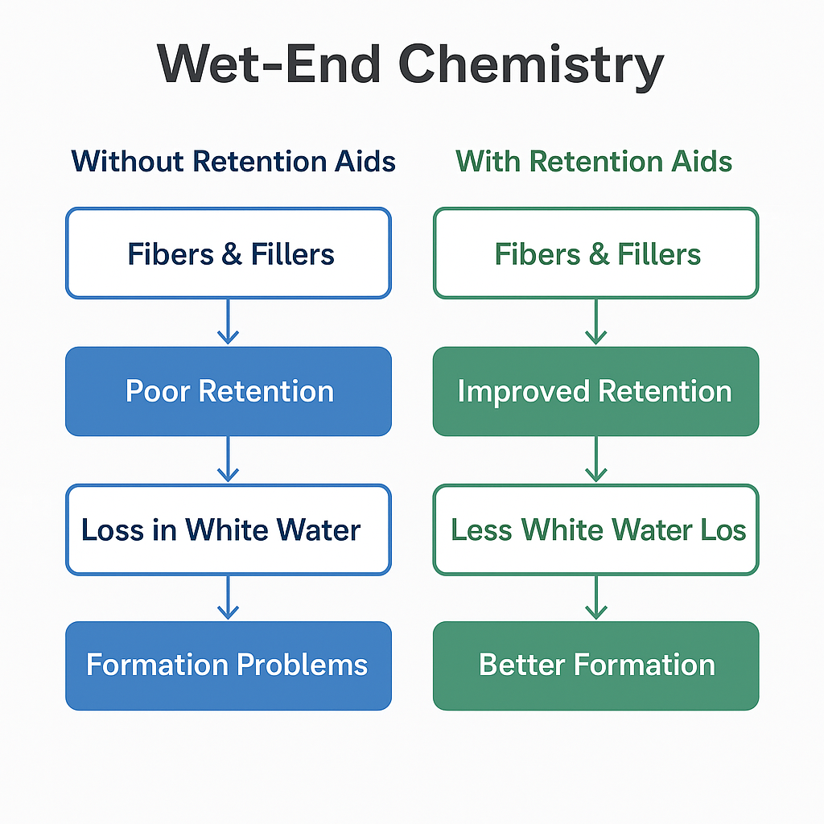

Types of Retention Aids Used in India

1. Cationic Polymers
These are widely used due to their strong charge attraction to negatively charged fiber and filler surfaces. Indian mills often prefer CPAMs due to availability and compatibility with acidic to neutral pH systems.

2. Colloidal Silica and Bentonite
Used in two-component retention systems, especially in mills targeting high-speed production and improved drainage.

3. Microparticle Systems
These combine polymers with small-sized inorganic particles to form robust flocs, ideal for high-ash recycled furnish used in Indian packaging and newsprint mills.

Importance of Retention Aids in the Indian Paper Industry
India’s paper industry faces:
- Rising fiber and filler costs
- Stricter pollution norms
- Chronic water shortages
Retention aids directly tackle these challenges by improving resource efficiency and reducing environmental impact.

Improving Fiber & Filler Retention

Benefits of High First-Pass Retention (FPR)
High FPR ensures that more fiber and filler stay on the sheet, reducing their loss to white water.

How Indian Mills Benefit
- Reduces material costs: Better use of expensive fillers like PCC
- Improves opacity and printability
- Reduces reject generation in QCS (Quality Control Systems)

Enhanced Drainage and Energy Savings
In India, energy efficiency is a top priority.

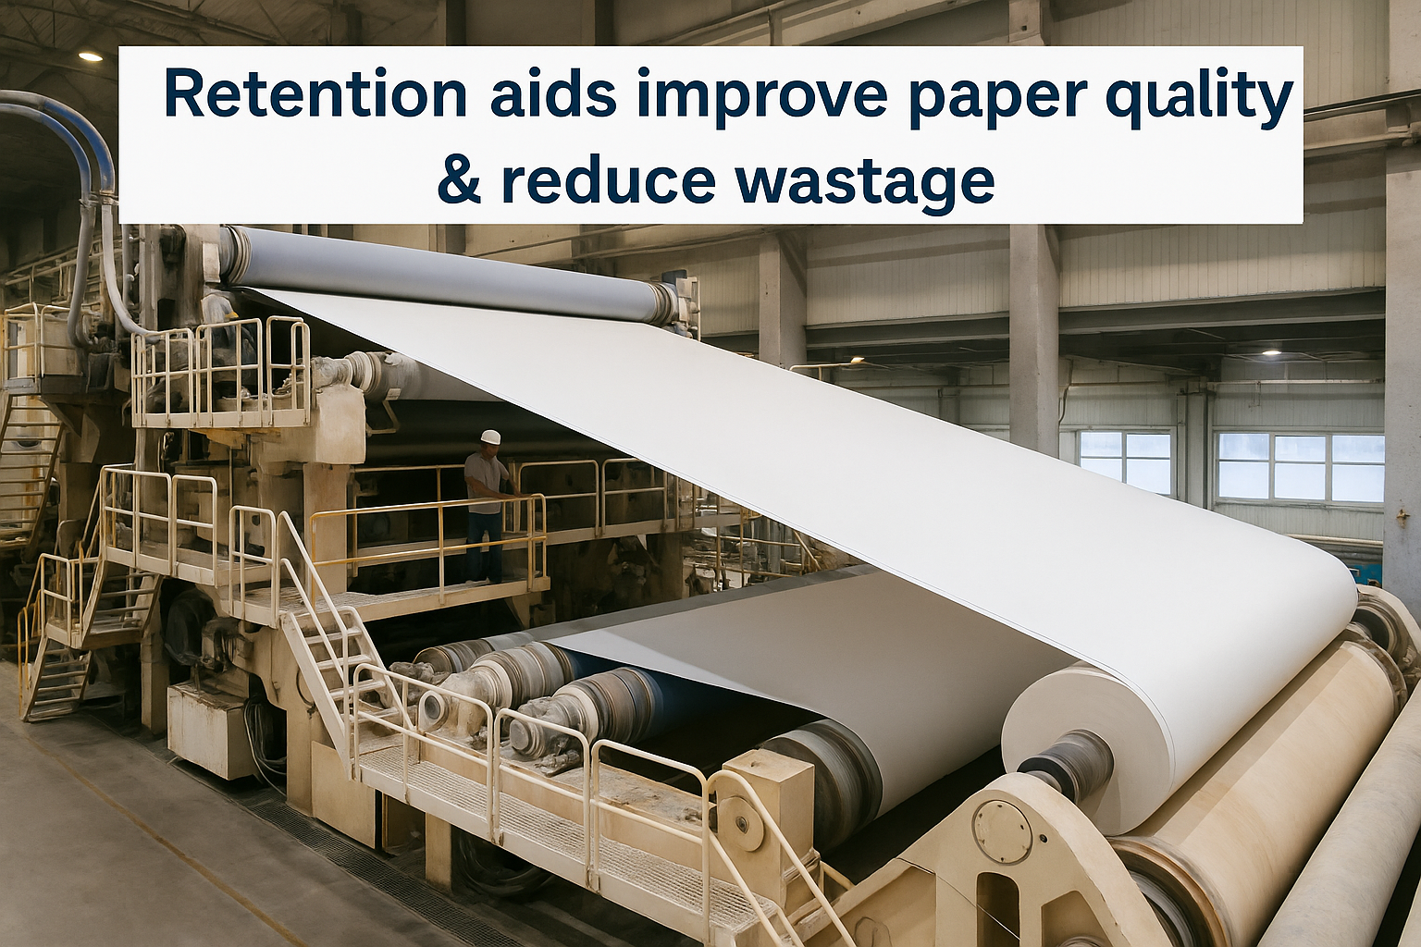

Faster Drying, Less Steam
Retention aids speed up drainage in the wire section, allowing faster drying with:
- Less steam
- Reduced fuel cost
- Better runnability of paper machines
This is especially beneficial for coal or biomass-fired boilers, common in Indian mills.

Better Formation and Sheet Quality
Improved retention leads to:
- Uniform fiber distribution
- Better sheet appearance
- Reduced streaks, holes, and fluff
Especially for Indian copier and printing paper manufacturers, better formation means higher acceptance rates and reduced rework.

Stabilizing the Wet-End System
Retention aids control the fine particles and colloids in the white water loop.

Cleaner Loop, Smoother Operation
- Less foaming
- Fewer deposits
- Consistent furnish characteristics
This is critical in multi-machine Indian paper mills where water loops are shared.

Minimizing Wastage in Indian Paper Mills
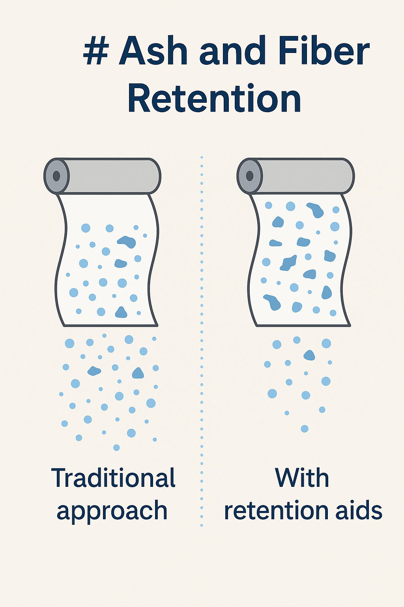

Reducing Fiber & Filler Loss
With better retention, white water becomes cleaner, reducing:
- Load on DAF/STP systems
- Filler replenishment needs
- Disposal costs

Environmental Compliance and Water Reuse

Reduced COD/BOD Load
By holding fillers and fibers in the sheet, retention aids reduce organic and inorganic solids in effluent.

Easier Effluent Treatment
Compliance with CPCB norms becomes easier, and mills can recycle more water internally.

Case Studies from Indian Paper Plants
In Tamil Nadu, a mid-sized paper mill using recycled OCC improved its FPR by 22% and reduced effluent turbidity by 35% after switching to a microparticle retention system.
Another northern Indian mill reported:
- 15% less filler loss
- 18% less drying steam
- Significantly cleaner felt life

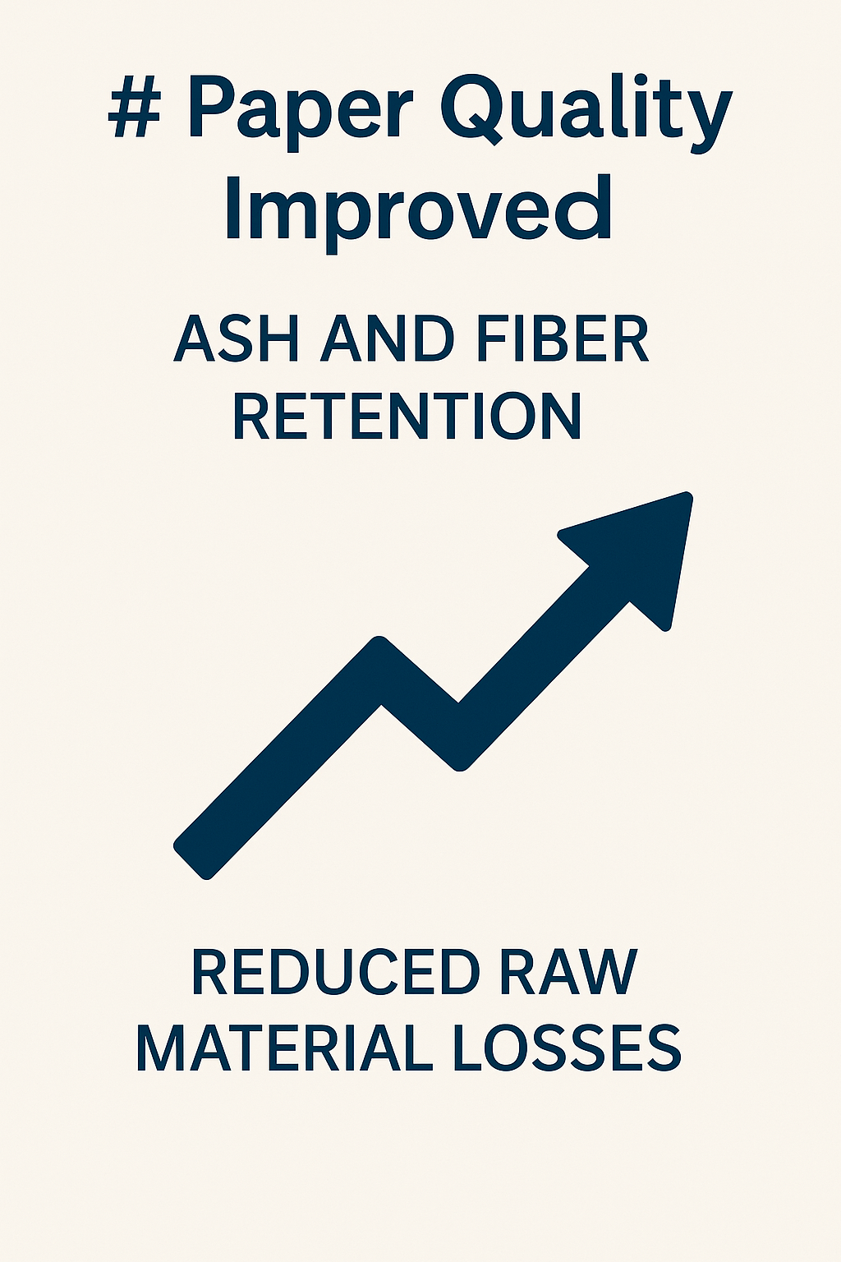

Conclusion: Driving Efficiency & Sustainability in Indian Papermaking
Retention aids are more than just chemical additives—they’re strategic tools that enhance paper quality, reduce operational waste, and support sustainability goals in the Indian paper industry. As mills across the country grapple with tightening regulations, increasing costs, and growing customer expectations, investing in the right retention aid system is a step forward.
To summarize the key benefits for Indian mills:
- Higher first-pass retention (FPR) leads to better use of fibers and fillers
- Improved drainage cuts energy use and boosts machine speed
- Cleaner water loops reduce chemical waste and environmental load
- More consistent formation improves end-product quality and acceptance rate
- Lower maintenance and downtime enhance production stability
Whether you're running a kraft linerboard plant in Gujarat or a recycled tissue mill in Tamil Nadu, retention aids can transform your performance matrix. Consider partnering with chemical suppliers to optimize your wet-end system with tailored retention and drainage solutions.

Frequently Asked Questions (FAQs)

1. What are retention aids used for in Indian paper mills?
Retention aids help retain fine particles like fibers, fillers, and other additives in the paper sheet during formation. They improve paper quality, reduce wastage, enhance drainage, and lower chemical and energy consumption.

2. How do retention aids help in reducing wastage?
By binding fillers and fibers effectively to the paper web, retention aids prevent their loss in white water. This minimizes raw material waste, reduces load on effluent treatment systems, and lowers operating costs.

3. Are retention aids suitable for recycled paper grades in India?
Yes, they are especially useful in recycled fiber-based mills. They handle high ash and ink content better, improve first-pass retention, and help tackle the unique challenges posed by secondary fiber furnishes.

4. Can retention aids help with effluent treatment compliance?
Absolutely. Retention aids reduce the total solids, BOD, and COD in wastewater by retaining organic and inorganic matter in the sheet. This makes it easier for mills to meet CPCB environmental discharge norms.

5. How do I choose the right retention aid system for my paper machine?
Selection depends on the furnish, paper grade, pH conditions, machine speed, and existing chemical program. Many Indian mills use pilot trials to test one-component or two-component systems for optimal performance.

6. Do retention aids reduce steam and energy usage?
Yes. By enhancing drainage and reducing water retention in the web, they speed up drying and reduce the energy needed for steam generation—especially vital in coal or biomass-fired systems.

📚 Sources and References
- TAPPI (Technical Association of the Pulp and Paper Industry)
  - Widely recognized for papermaking best practices, including retention aid systems.
  - https://www.tappi.org
- CPPRI – Central Pulp & Paper Research Institute (India)
  - Research on paper chemistry, retention systems, and environmental compliance in Indian mills.
  - http://cppri.res.in
- Journal of Cleaner Production – Elsevier
  - Peer-reviewed studies on retention aids, wastewater reduction, and energy optimization.
  - e.g., “Effect of polymeric retention aids in papermaking processes.”
- Indian Paper Manufacturers Association (IPMA)
  - Data on energy use, effluent norms, and mill operations across India.
  - https://ipma.in
- Nalco Water (Ecolab) Technical Papers
  - Whitepapers and field trials on microparticle retention systems and drainage aids.
- Kemira & BASF Product Literature
  - Global leaders in paper chemicals; product case studies and retention aid system designs.
- Kunimine Industries / Balaji Chem Solutions (India)
  - Indian suppliers of bentonite and cationic retention aid solutions, respectively.
- MDPI Open Access Journals – Molecules / Polymers
  - Scientific research on molecular mechanisms of flocculation in paper formation.
  - e.g., https://www.mdpi.com/journal/polymers
- International Journal of Scientific & Engineering Research (IJSER)
  - Papers on optimization of chemical usage in Indian paper mills.
- CPCB (Central Pollution Control Board, India)
  - Regulatory framework for effluent discharge and water reuse in the pulp and paper industry.
  - https://cpcb.nic.in

